# Project Design Phase-II Data Flow Diagram & User Stories

|  |  |
| --- | --- |
| **Date** | 19-10-2022 |
| **Team ID** | PNT2022TMID04980 |
| **Project Name** | Personal Expense Tracker Application |
| **Maximum Marks** | 4 marks |

**Data Flow Diagrams:**

A Data Flow Diagram (DFD) is a traditional visual representation of the information flows within a system. A neat and clear DFD can depict the rightamount of the system requirement graphically. It shows how data enters and leaves the system, what changes the information, and where data is stored.

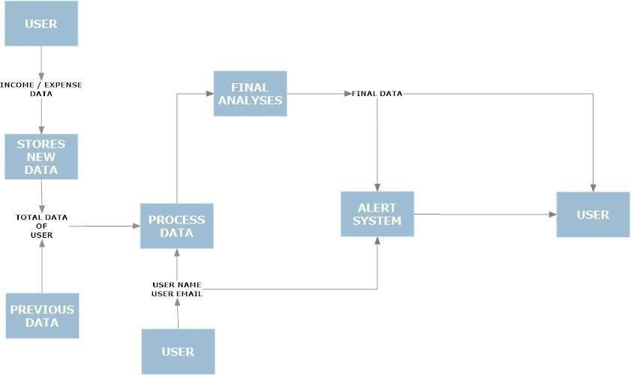

# User Stories

Use the below template to list all the user stories for the product.

|  |  |  |  |  |  |  |
| --- | --- | --- | --- | --- | --- | --- |
| **User Type** | **Functional Requireme nt**  **(Epic)** | **User Story Number** | **User Story / Task** | **Acceptance criteria** | **Priority** | **Release** |
| Customer (Mobile user &web user ) | Registration | USN-1 | As a user, I can register for the application by entering my email, password, and confirmingmy password. | I can access my account / dashboard | High |  |
|  |  | USN-2 | As a user, I will receive confirmation emailonce I have registered for the application | I can receive confirmationemail & click confirm | High |  |
|  |  | USN- 3 | As a user, I can register for the application through Facebook | I can register & access the dashboard with Facebook  Login | Low |  |
|  | Login | USN - 4 | As a user, I can log into the application byentering email & password | I can access the application | High |  |
|  | Dashboard | USN - 5 | As a user I can enter my income and expenditure details. | I can view my daily expenses | High |  |
| Customer Care Executive |  | USN – 6 | As a customer care executive I can solve the log in issues and other issues of the application. | I can provide support or  solution at any time 24*7 | Medium |  |
| Administrator | Application | USN - 7 | As a administrator I can upgrade or update the application. | I can fix the bug which arises for the customers  and users of the application | Medium |  |